Cairo University  
Faculty of Computers and Artificial Intelligence

**CS251**

**Intro. to Software Engineering**

Project Name

Software Requirements Specifications

Version 1.0

Team Names and Emails and Phone of Team Leader

Month & Year

Contents

Team 3

Document Purpose and Audience 3

Introduction 3

Software Purpose 3

Software Scope 3

Definitions, acronyms, and abbreviations 4

Requirements 5

Functional Requirements 5

Non Functional Requirements 6

System Models 6

Use Case Model 7

Enriched User Stories 8

System Navigation Map 34

Tools 34

Ownership Report 35

# Team

|  |  |  |  |
| --- | --- | --- | --- |
| **ID** | **Name** | **Email** | **Mobile** |
| 20210420 | Mina Maged Faris | Menamaged669@gmail.com |  |
| 20211012 | Eslam Sayed | esla889900@gmail.com |  |

# Document Purpose and Audience

## Purpose

The purpose of this document is to clarify software requirements that are agreed upon by the stakeholders by specifying the needed functionalities of the software to minimize development time and cost by making the requirements clear.

## Audience

* Software Development Team
* Stakeholders

# Introduction

## Software Purpose

The purpose of Toffee is to sell sweets and candy online whether it’s by kilo or a package and Link between seller and buyer.

## Software Scope

* The major feature of this system is to sell candy and sweets online whether it’s by kilo or a package.
* It’s also had an admin to control the amount of candy left or adding a new amount and control prices of candy and so on.

## Definitions, acronyms, and abbreviations

|  |  |
| --- | --- |
| **Phrase** | **Definition** |
| Smart Wallets | An electronic device, online service, or software program that allows one party to make electronic transactions with another party bartering digital currency units for goods and services. |
| OTP | **One Time Password** it's a temporary, secure PIN-code sent to you via SMS or e-mail that is valid only for one session used to verify an email or phone number. |
| shopping cart | Is a place where you put the things you want to buy in. |
| sealed items | sealed item means an unbroken or unopened item which cannot be opened without damaging the container. |
| Loose items | free or released from confinement or restraint not in a package. |
| gift voucher | Is a card or piece of paper that you buy at a shop and give to someone, which entitles the person to exchange it for goods worth the same amount |
| gift voucher code | Is a unique code and can be redeemed once when making an order to reduce the total price by the value of the voucher. |
| Loyalty points | Is points give to a customer after buying something only give by admin and the customer can redeem it with candy and sweets. |
| catalog | It’s like a main page that contain all goods. |
| "re-corder" button | makes the same exact order with the same exact conditions. |
| Maintainability | The ease with which a software system or component can be modified to correct faults, improve performance or other attributes, or adapt to a changed environment." |
| Scalability | The ability of the software to support a growing number of users while offering good performance. |
| Usability | The degree to which a software can be used by specified consumers to achieve quantified objectives with effectiveness, efficiency, and satisfaction in a quantified context of use. |
| Portability | Portability defines how a system, or its element can be launched on one environment or another. |
| Availability | Availability measures the ability of a piece of equipment to be operated if needed. |
| Reliability | reliability measures the ability of a piece of equipment to perform its intended function for a specific interval without failure |

# Requirements

## Functional Requirements

|  |  |
| --- | --- |
| **Requirement ID** | **Requirement Statement** |
| FR01 | The application should have a login/sign-up system and screen and make a login or sign up.   * check if the user is signed up make them go to the next page if not make him sign up and then login. * Registration requires secure password guidelines. Registration is completed by sending an OTP to the email used |
| FR02 | After the login the next screen should display the goods with its price. |
| FR03 | The user has the option to buy by packet or kilo. |
| FR04 | The user can put the items he wants to buy in shopping cart. |
| FR05 | The user can pay in different ways.   * eWallet (smart wallets) * credit card * in delivery |
| FR06 | A system admin can update catalog with new items, cancel items or update item info. |
| FR07 | The user can buy sealed items or Loose items. |
| FR08 | Admin can view all orders, set loyalty points scheme, suspend a user, and view statistics.   * Statistics provide store owners with a view of how the store is doing. This may include daily and monthly sales, sales of each item in a period among other statistics. |
| FR09 | user can re-order a previous order |
| FR10 | Upon making an order, shoppers must specify the shipping address; if it is the same address registered on their profile or another address. |

## Non Functional Requirements

|  |  |
| --- | --- |
| Measure | Details |
| **Performance** | * The Sign-in/sign-up screen should take about 7 seconds to load. * Every panel in the system should take less than 10 seconds to load. * Confirmation code must be sent within 2 minutes. * Reserving or canceling a order must take 20 seconds. * The system should be able to manage a high volume of requests and transactions with minimal delays or performance concerns. |
| **Scalability** | The system should be able to scale up or down to meet changing demand. |
| **Security** | The system should protect sensitive client data and maintain the security of all transactions like storing the RNR encrypted and storing the way that the passenger pays encrypted (credit card, PayPal account,……….). |
| **Maintainability** | The system should be simple to maintain and update, with low downtime.  The system should have a 90% chance of maintainability for 1 day. Which means that if a component in the system had a critical issue, there is a 95% chance that this component will be fixed in 2 days. |
| **Reliability and availability** | The system should be active 93% of the day.  The system should be always available, with as little downtime as possible for maintenance or updates. |
| **Usability** | The system should be simple to use for both customers and staff, with a simple and straightforward interface. |

# System Models

## Use Case Model

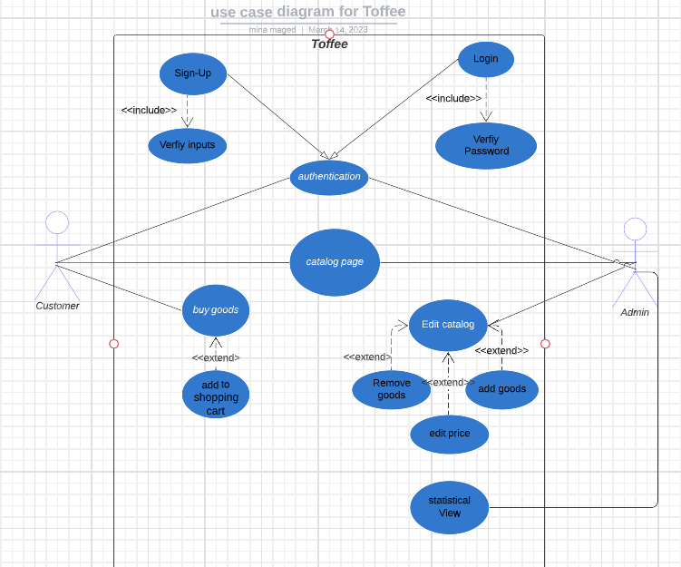

## Enriched User Stories

* **User Story #1**

|  |  |
| --- | --- |
| **User Story ID** | US #1 |
| **User Story Name** | Log in |
| **Actors** | customer or employee |
| **Description** | **As** a customer or employee  **I like** to be able to log in  **So I can use the app** |
| **Per condition** |  |
| **Post condition** |  |
| **Acceptance Criteria** | **Given** a logged-out system user and I’m on the Sign-In page  **When** I fill in the “Username” and “Password” fields with my authentication credentials and I click the Log-In button  **Then** the system signs me in |

* **Scenarios**

**Normal Scenario**

|  |  |
| --- | --- |
| **Actor Action** | **System Response** |
| 1- User clicks on log in |  |
|  | 2- System displays log in page  3- System display boxes to input username and password |
| 4 - User fills in the boxes |  |
|  | 5 - System verifies the user information |
| 6- - System accesses user to app functionalities |  |

**Exceptional Scenario**

|  |  |
| --- | --- |
| **Actor Action** | **System Response** |
| 1- User clicks on log in |  |
|  | 2- System displays log in page  3- System display boxes to input username and password |
| 4 - User fills in the boxes |  |
|  | 5- - System finds input information invalid  6- - System displays “Please enter valid username/password.” message |

* **Screen Design**

* **Data Dictionary:**

| **Element Label** | **Type/Length** | **Data Validation / Business Rule** |
| --- | --- | --- |
| Username field | Text <100 Characters | Structured Text |
| Password field | Text <100 Characters | Structured Text |

**____________________________________________________________________________**

* **User Story #2**

|  |  |
| --- | --- |
| **User Story ID** | US #2 |
| **User Story Name** | Sign-up |
| **Actors** | customer |
| **Description** | **As** a customer or employee  **I like** to be able to lo sign-up  **So I can use the app** |
| **Per condition** |  |
| **Post condition** |  |
| **Acceptance Criteria** | **Given** I’m a logged-out system user and I’m on the Sign-up page  **When** I fill in the sign up information fields with my credentials and I click sign up  **Then** the system signs me up |

* **Scenarios**

**Normal Scenario**

|  |  |
| --- | --- |
| **Actor Action** | **System Response** |
| 1- User clicks on sign-up |  |
|  | 2- System displays sign-up page  3-System display boxes to input sign up information |
| 4 - User fills the boxes |  |
|  | 5 - System verifies the user information |
|  | 6- System saves user information in the database |

**Exceptional Scenario**

|  |  |
| --- | --- |
| **Actor Action** | **System Response** |
| 1- User clicks on sign-up |  |
|  | 2- System displays sign-up page  3- -System display boxes to input sign up information |
| 4 - User fills in the boxes |  |
|  | 5- - System finds input information invalid  6- System displays “Please enter valid information.” message |

* **Screen Design**

* **Data Dictionary:**

| **Element Label** | **Type/Length** | **Data Validation / Business Rule** |
| --- | --- | --- |
| Username field | Text <100 Characters | Structured Text |
| Email | Text <100 Characters | Email must contain ‘@’ sign and ‘.com’ at the end and must be valid email send a confirmation message to it |
| Phone Number | Alphanumeric < 100 Characters | Integer > 0 and confirm via text message |
| Password | Text <100 Characters | Password confirmation and must include an uppercase letter, numbers and/or special characters |
| Confirm Password | Text <100 Characters | It must be matched with the password |

**_____________________________________________________________________________________**

* **User Story #3**

|  |  |
| --- | --- |
| **User Story ID** | US #3 |
| **User Story Name** | Search |
| **Actors** | customer |
| **Description** | **As** a customer  **I like** to be able to search for things I like.  **So I save time** |
| **Per condition** |  |
| **Post condition** |  |
| **Acceptance Criteria** | **Given** a Search bar  **When** I search  **Then** the search for me |

* **Scenarios**

**Normal Scenario**

|  |  |
| --- | --- |
| **Actor Action** | **System Response** |
| 1- User clicks on search |  |
|  | 2- System displays the item. |
| 4 - User press to the item |  |
|  | 5 - System takes him to the item page he wants |

**Exceptional Scenario**

|  |  |
| --- | --- |
| **Actor Action** | **System Response** |
| 1- User clicks on search |  |
|  | 2- System displays the item does not found |

* **Screen Design**

* **Data Dictionary:**

| **Element Label** | **Type/Length** | **Data Validation / Business Rule** |
| --- | --- | --- |
| Search field | Text <100 Characters | Structured Text |
| Description field | Text <500 Characters | Structured Text |

**_____________________________________________________________________________________**

* **User Story #4**

|  |  |
| --- | --- |
| **User Story ID** | US #4 |
| **User Story Name** | Add to shopping list |
| **Actors** | customer |
| **Description** | **As** a customer  **I like** to be able to add to shopping list and continuo shopping.  **So I don’t forget the buy the things I like** |
| **Per condition** |  |
| **Post condition** |  |
| **Acceptance Criteria** | **Given** a Shopping list  **When** I add items to shopping list  **Then it add to my shopping list** |

* **Scenarios**

**Normal Scenario**

|  |  |
| --- | --- |
| **Actor Action** | **System Response** |
| 1- User clicks on add to shipping list |  |
|  | 2- System Add item to shopping list |
| 4 - User go back and continuo shopping |  |
|  | 5 - System takes him to the main page |

**No Exceptional Scenario for this Case**

* **Screen Design**

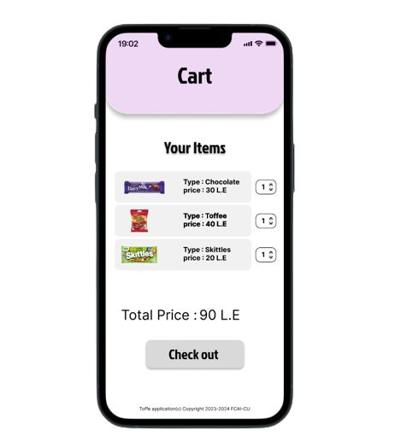**_______________________________________________________________________**

* **User Story #5**

|  |  |
| --- | --- |
| **User Story ID** | US #5 |
| **User Story Name** | Payment |
| **Actors** | customer |
| **Description** | **As** a customer  **I like** to be able to Pay easily and in different ways.  **So I became satisfied** |
| **Per condition** |  |
| **Post condition** |  |
| **Acceptance Criteria** | **Given** a payment method.  **When** I pay  **Then** the System Displays many options. |

* **Scenarios**

**Normal Scenario**

|  |  |
| --- | --- |
| **Actor Action** | **System Response** |
| 1- User clicks on pay |  |
|  | 2- System displays payment methods |
| 3 - User choose to payment method |  |
|  | 4 - System saves payment method  5- System send OTP message to phone number. |

**Exceptional Scenario**

|  |  |
| --- | --- |
| **Actor Action** | **System Response** |
| 1- User clicks on pay |  |
|  | 2- System displays payment methods |
| 3 - User choose to payment method |  |
|  | 4- If user chooses to pay in any online method  And there is not enough money system  displays sorry not enough money. |

* **Screen Design**

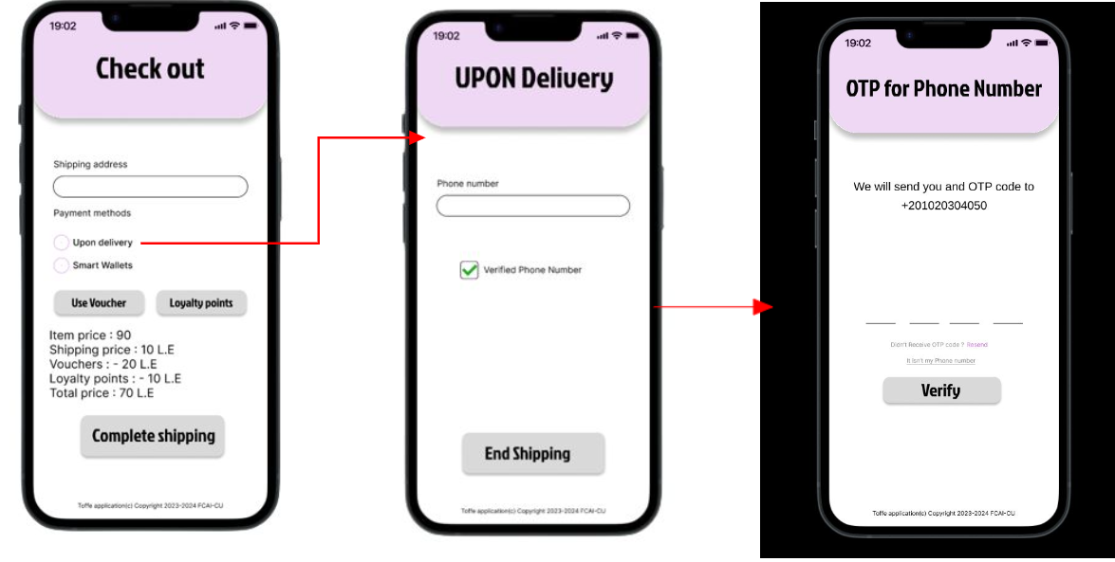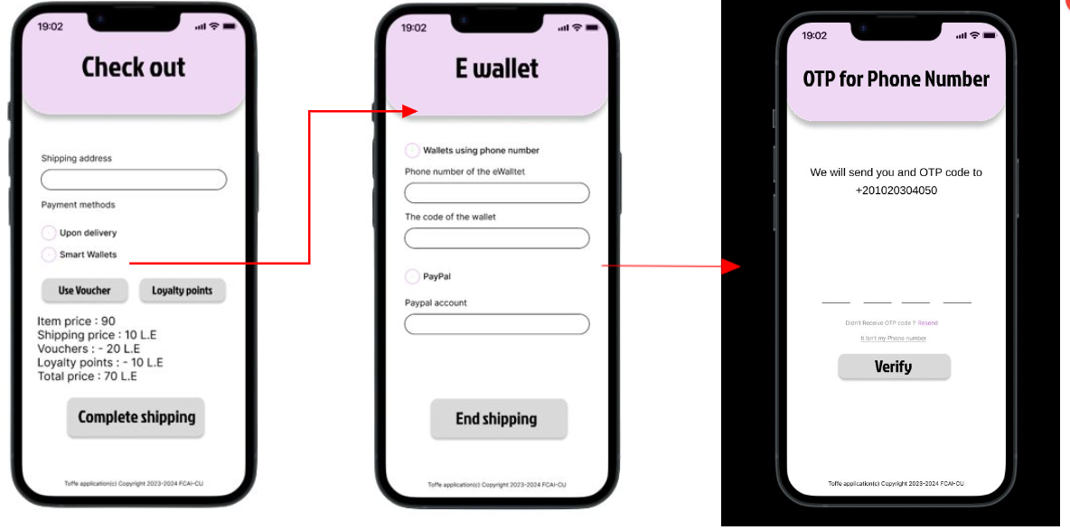

* **Data Dictionary:**

| **Element Label** | **Type/Length** | **Data Validation / Business Rule** |
| --- | --- | --- |
| Shipping address | Text <100 Characters | Structured Text |
| Phone Number | Alphanumeric < 100 Characters | Integer > 0 and confirm via text message |
| Code of Wallet | Alphanumeric < 100 Characters | Don’t save the order until you make sure it’s a valid wallet |

**_____________________________________________________________________________________**

* **User Story #6**

|  |  |
| --- | --- |
| **User Story ID** | US #6 |
| **User Story Name** | Voucher and Loyalty Points |
| **Actors** | customer |
| **Description** | **As** a customer  **I like** to be able to have some Vouchers and loyalty points.  **So I have some Price reductions.** |
| **Per condition** |  |
| **Post condition** |  |
| **Acceptance Criteria** | **Given** a Voucher and Loyalty Points.  **When** buying  **Then** the System Displays Voucher and Loyalty Points and reduce item price. |

* **Scenarios**

**Normal Scenario**

|  |  |
| --- | --- |
| **Actor Action** | **System Response** |
| 1- User clicks on Voucher or Loyalty Points |  |
|  | 2- System displays Voucher or Loyalty Points Pages |
| 3 - User input boxes |  |
|  | 4 - System makes the Correct price reduction.  5- System Displays the new price. |

**Exceptional Scenario**

|  |  |
| --- | --- |
| **Actor Action** | **System Response** |
| 1- User clicks on Voucher or Loyalty Points |  |
|  | 2- System displays Voucher or Loyalty Points Pages |
| 3 - User input boxes |  |
|  | 4- System Response sorry invalid code |

* **Screen Design**

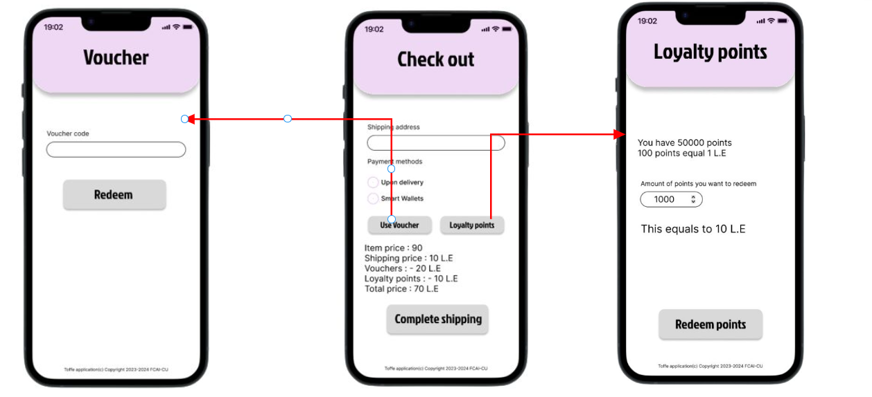

* **Data Dictionary:**

| **Element Label** | **Type/Length** | **Data Validation / Business Rule** |
| --- | --- | --- |
| Voucher Code | Text <100 Characters | Structured Text and check if it still valid or not. |

**_____________________________________________________________________________________**

* **User Story #7**

|  |  |
| --- | --- |
| **User Story ID** | US #7 |
| **User Story Name** | Add Items |
| **Actors** | Admin |
| **Description** | **As** an Admin  **I like** to be able to Update the catalog by adding items.  **So I modify the main page.** |
| **Per condition** |  |
| **Post condition** |  |
| **Acceptance Criteria** | **Given** a page to admin.  **When** updating the catalog by adding.  **Then** the System Add to Catalog. |

* **Scenarios**

**Normal Scenario**

|  |  |
| --- | --- |
| **Actor Action** | **System Response** |
| 1- Admin After choosing Add. |  |
|  | 2- System displays add page. |
| 3 – Admin input boxes |  |
|  | 4 - System Add the item. |

**NO Exceptional Scenario for this Case**

* **Screen Design**

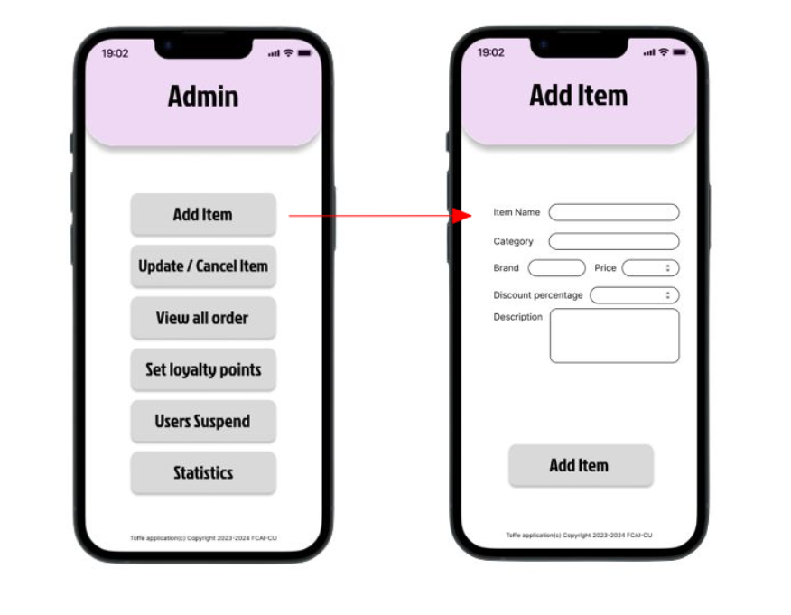

* **Data Dictionary:**

| **Element Label** | **Type/Length** | **Data Validation / Business Rule** |
| --- | --- | --- |
| Item Name | Text <100 Characters | Structured Text |
| Category | Text <100 Characters | Structured Text |
| Discount percentage | Numeric | Only numbers |
| Price | Numeric | Only numbers |
| Description | Text <100 Characters | Structured Text |

**_____________________________________________________________________________________**

* **User Story #8**

|  |  |
| --- | --- |
| **User Story ID** | US #8 |
| **User Story Name** | Update/Cancel Catalog |
| **Actors** | Admin |
| **Description** | **As** an Admin  **I like** to be able to Update and Delete items in the catalog.  **So I modify the main page.** |
| **Per condition** |  |
| **Post condition** |  |
| **Acceptance Criteria** | **Given** an Update/Cancel Page.  **When** Update/Cancel the catalog.  **Then** the System Update/Cancel Catalog. |

* **Scenarios**

**Normal Scenario**

|  |  |
| --- | --- |
| **Actor Action** | **System Response** |
| 1- Admin After choosing Update/Cancel catalog. |  |
|  | 2- System displays Update/Cancel catalog. |
| 3 – Admin input boxes |  |
|  | 4 - System Update/Cancel the item. |

**Exceptional Scenario**

|  |  |
| --- | --- |
| **Actor Action** | **System Response** |
| 1- Admin After choosing Update/Cancel catalog. |  |
|  | 2- System displays Update/Cancel catalog. |
| 3 – Admin input boxes |  |
|  | 4- System Response sorry invalid inputs. |

* **Screen Design**

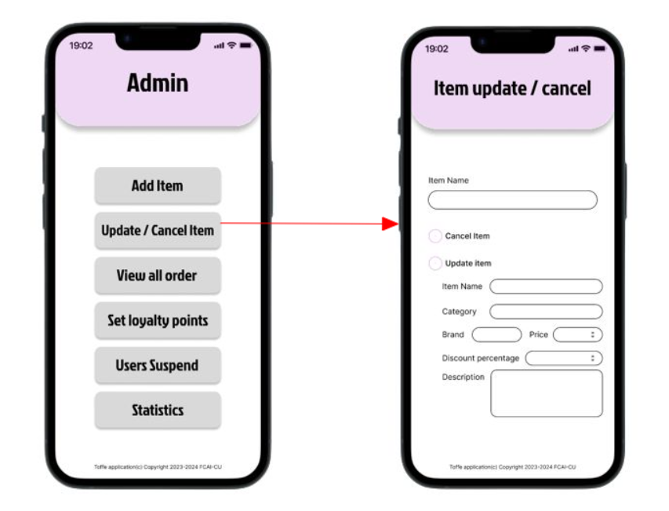

* **Data Dictionary:**

| **Element Label** | **Type/Length** | **Data Validation / Business Rule** |
| --- | --- | --- |
| Item Name | Text <100 Characters | Structured Text |
| Category | Text <100 Characters | Structured Text |
| Discount percentage | Numeric | Only numbers |
| Price | Numeric | Only numbers |
| Description | Text <100 Characters | Structured Text |

* **User Story #9**

|  |  |
| --- | --- |
| **User Story ID** | US #9 |
| **User Story Name** | View Orders |
| **Actors** | Admin |
| **Description** | **As** an Admin  **I like** to be able to View Orders.  **So I can inform the delivery Guy.** |
| **Per condition** |  |
| **Post condition** |  |
| **Acceptance Criteria** | **Given** a View Orders Page.  **When** View Orders.  **Then** the System Displays the Orders . |

* **Scenarios**

**Normal Scenario**

|  |  |
| --- | --- |
| **Actor Action** | **System Response** |
| 1- Admin After choosing View Orders. |  |
|  | 2- System displays Orders. |

**NO Exceptional Scenario For this Case.**

* **Screen Design**

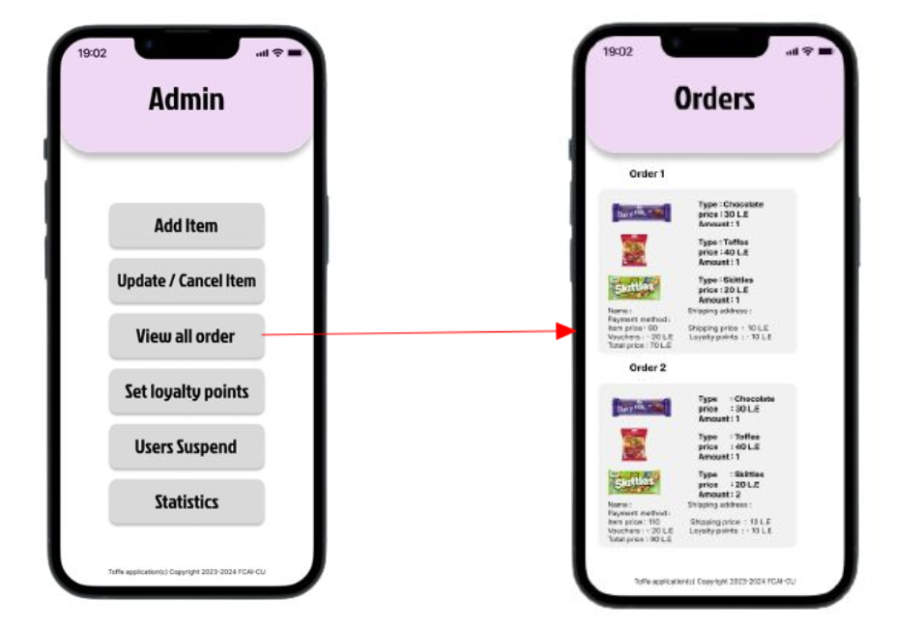

* **User Story #10**

|  |  |
| --- | --- |
| **User Story ID** | US #10 |
| **User Story Name** | Set Loyalty points |
| **Actors** | Admin |
| **Description** | **As** an Admin  **I like** to be able to Set Loyalty points.  **So customer can have a price reduction.** |
| **Per condition** |  |
| **Post condition** |  |
| **Acceptance Criteria** | **Given** a Set Loyalty points page.  **When** Setting Loyalty points.  **Then** the System Set Loyalty points to the items and then give the loyalty points to the customer. |

* **Scenarios**

**Normal Scenario**

|  |  |
| --- | --- |
| **Actor Action** | **System Response** |
| 1- Admin After choosing Set Loyalty points. |  |
|  | 2- System displays Set Loyalty points page. |
| 3 – Admin input boxes |  |
|  | 4 - System Add the Loyalty points to the Items. |

**NO Exceptional Scenario for this Case**

* **Screen Design**

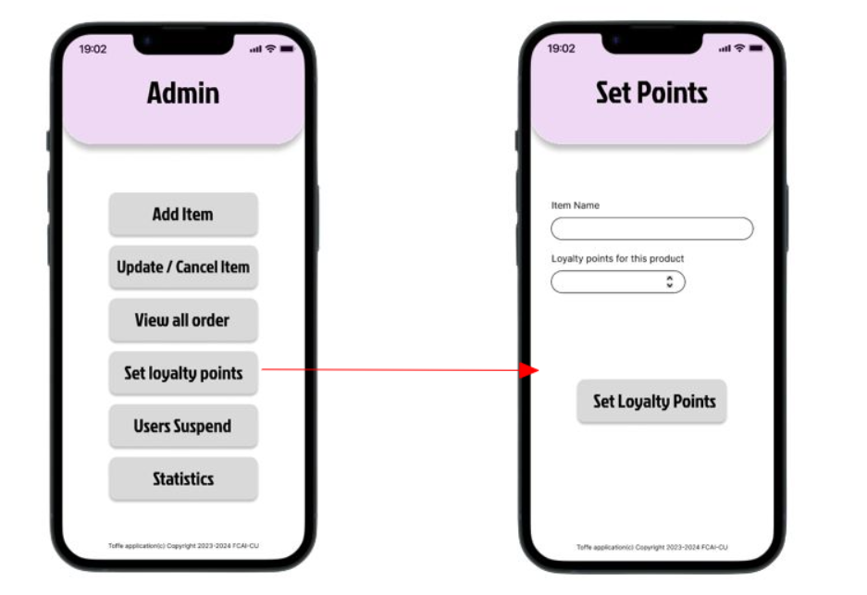

* **Data Dictionary:**

| **Element Label** | **Type/Length** | **Data Validation / Business Rule** |
| --- | --- | --- |
| Item Name | Text <100 Characters | Structured Text |
| Loyalty Points | Numbers | Numbers only |

**_____________________________________________________________________________________**

* **User Story #11**

|  |  |
| --- | --- |
| **User Story ID** | US #11 |
| **User Story Name** | User Suspend |
| **Actors** | Admin |
| **Description** | **As** an Admin  **I like** to be able to see User Suspend. |
| **Per condition** |  |
| **Post condition** |  |
| **Acceptance Criteria** | **Given** a User Suspend page.  **When** Seeing the User Suspend page.  **Then** the System Displays the User Suspend page. |

* **Scenarios**

**Normal Scenario**

|  |  |
| --- | --- |
| **Actor Action** | **System Response** |
| 1- Admin After choosing User Suspend page. |  |
|  | 2- System displays User Suspend page. |

**NO Exceptional Scenario for this Case**

* **Screen Design**

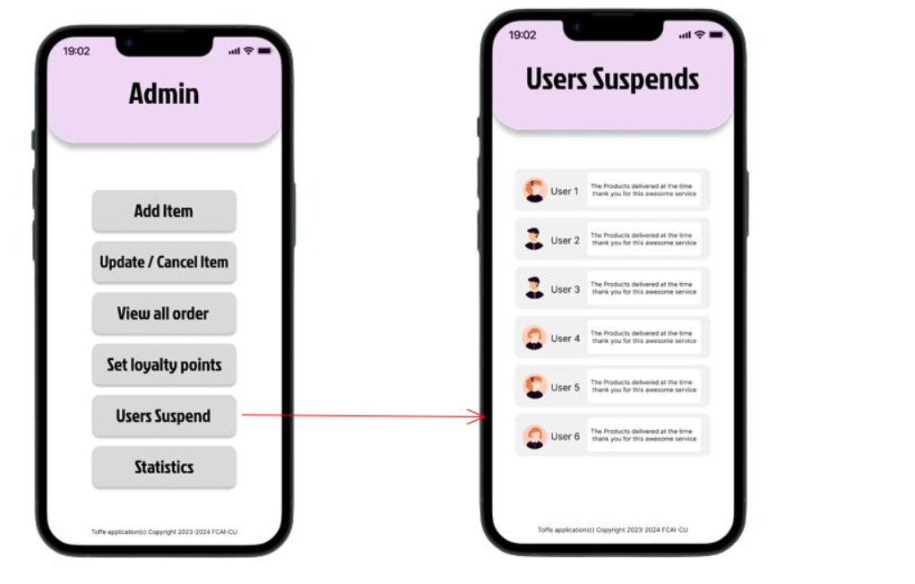

**_____________________________________________________________________________________**

* **User Story #12**

|  |  |
| --- | --- |
| **User Story ID** | US #12 |
| **User Story Name** | Statistics |
| **Actors** | Admin |
| **Description** | **As** an Admin  **I like** to be able to see Statistics.  **So I can know which item sold the most and other things related to marketing and decision support.** |
| **Per condition** |  |
| **Post condition** |  |
| **Acceptance Criteria** | **Given** a Statistics page.  **When** seeing the Statistics page.  **Then** the System Displays which Statistics I want. |

* **Scenarios**

**Normal Scenario**

|  |  |
| --- | --- |
| **Actor Action** | **System Response** |
| 1- Admin After choosing Statistics page. |  |
|  | 2- System displays User Suspend page. |
| 3-Admin chooses which type of statistics he wants |  |
|  | 4-System Displays type of statistics |

**NO Exceptional Scenario for this Case**

* **Screen Design**

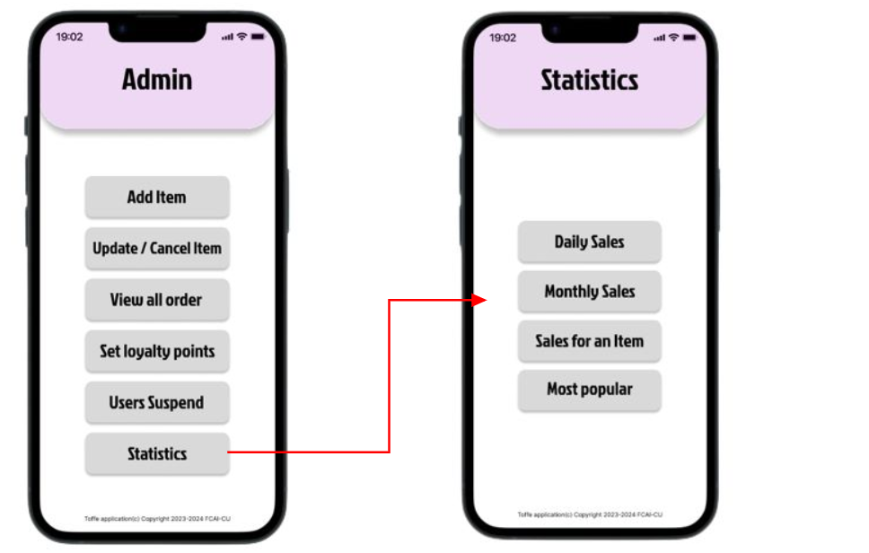

**_____________________________________________________________________________________**

## System Navigation Map

## 

# Tools

* Lucid chart
* www.mockflow.com for System Navigation Map
* wireframepro.mockflow.com
* Figma UI

# Ownership Report

|  |  |
| --- | --- |
| **Student** | **Items he created** |
| Mina Maged Faris | **Use Case Model, Functional Requirements, Document Purpose and Audience,**  **Introduction**  **And Some** **Definitions.** |
| Eslam Sayed | **Non-Functional Requirements, some definitions**  **System Navigation Map and tools** |